
Bachelor of Computer Applications
Semester – V
Business Analytics
Experiment No.: 3
Title: Importing and Integrating Business Datasets from Files &
MySQL into PowerBI

Submitted By:
Name: Thukivakam Chaturya
Reg. No: 2411021240045
Date: 04-09-2026

Submitted To:
Faculty Name: Mr. Aman Kumar Sharma

Department of Computer Application
Alliance University
Chandapura - Anekal Main Road, Anekal
Bengaluru – 562106

Experiment No.: 3
Importing and Integrating Business Datasets from Files &
MySQL into PowerBI
Github Link: https://github.com/Chaturyathukivakam/Business-Analytics

Problem Statement
As a Data Analyst in a retail company, I worked on integrating business data from different sources into Power BI Desktop. The main objective of the project was to connect Power BI with Excel/CSV files and a MySQL database, prepare the data, and create basic visualizations to analysis retail sales performance.
For the MySQL source, I created my own SQL database, tables, and queries to store and retrieve the required retail data.

Steps Followed
Step 1: Data Collection
For this project, I used two main data sources:
- MySQL Database – I created my own database, tables, and records using SQL queries.
- CSV File – I imported additional retail data stored in CSV format.
The data included information related to products, customers, stores, and sales transactions.
Step 2: Data Import and Connection
- Opened Power BI Desktop.
- Imported Excel and CSV files using Get Data.
- Connected Power BI to my MySQL database.
- Imported the required MySQL tables created using my own SQL queries.
- Verified that all data was loaded successfully.
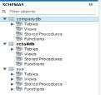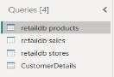

Step 3: Data Cleaning and Transformation
- Opened Power Query Editor.
- Checked data types and removed unnecessary/duplicate data.
- Cleaned and applied the changes.

Step 4: Data Modeling
- Created relationships between Sales, Customer, and Product tables.
- Verified one-to-many relationships.
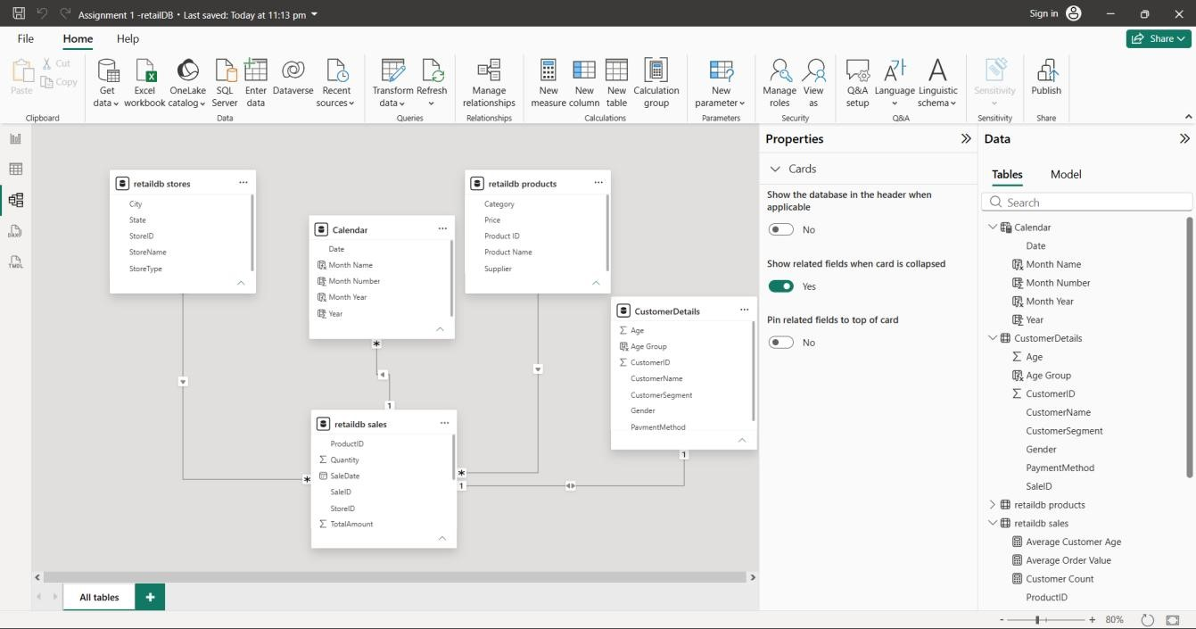

Step 5: Dashboard Development
- KPI Cards: Total Sales, Quantity, Orders, and Customers.
- Sales Analysis: Product, City, and Category-wise sales.
- Customer Analysis: Gender, Payment Method, Age Group, and Customer Segment.
- Regional Analysis: Sales and Orders by City.
- Store Analysis: Mall vs. Standalone stores.
- Interactive Filters: Month-Year and Category slicers.
- 3-Page Dashboard: Sales, Customer, and Store/Regional analysis.

Output
- The final Power BI dashboard provides:
- Total Sales Performance
- Customer Analysis
- Product-wise Sales Analysis
- Store-wise Sales Performance
- Monthly Sales Trends
- Interactive Filters and Slicers
The dashboard enables management to monitor business performance and make data-driven decisions effectively.
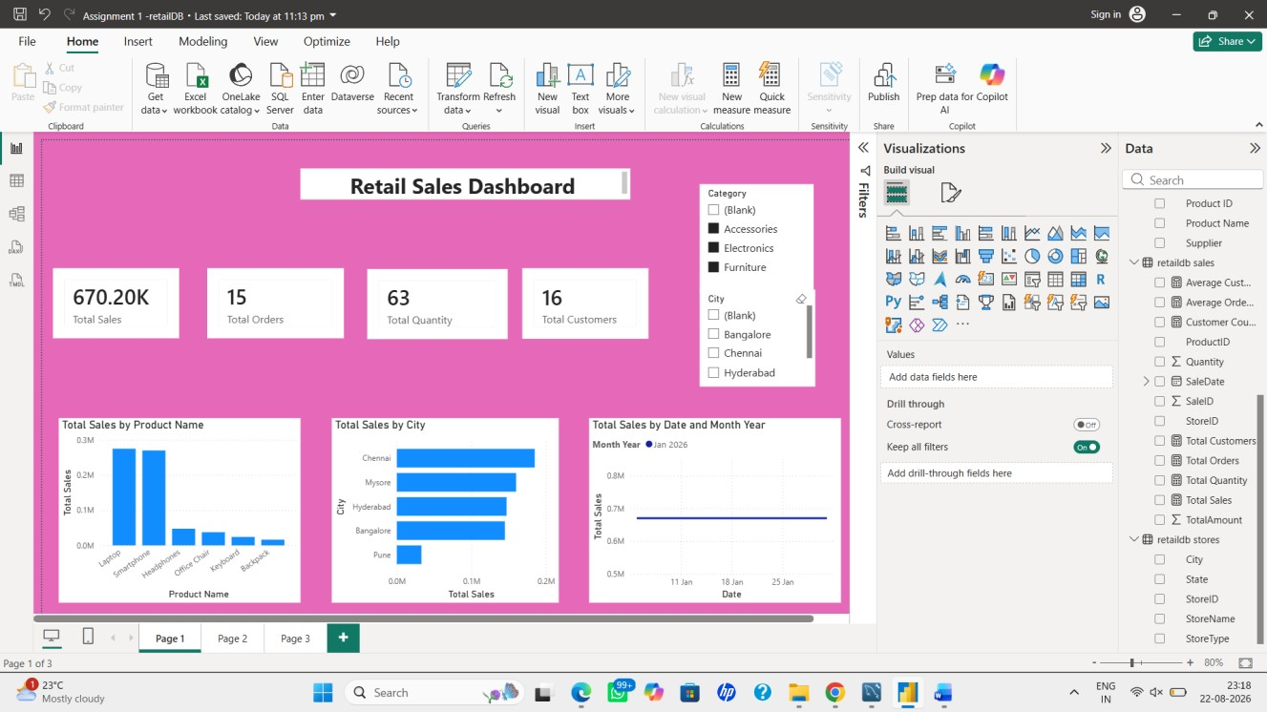

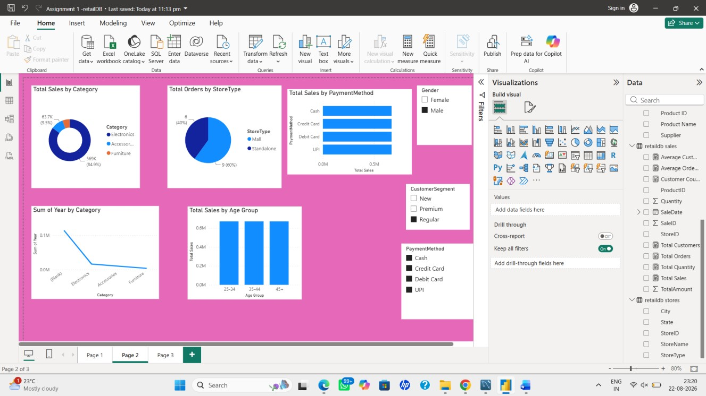

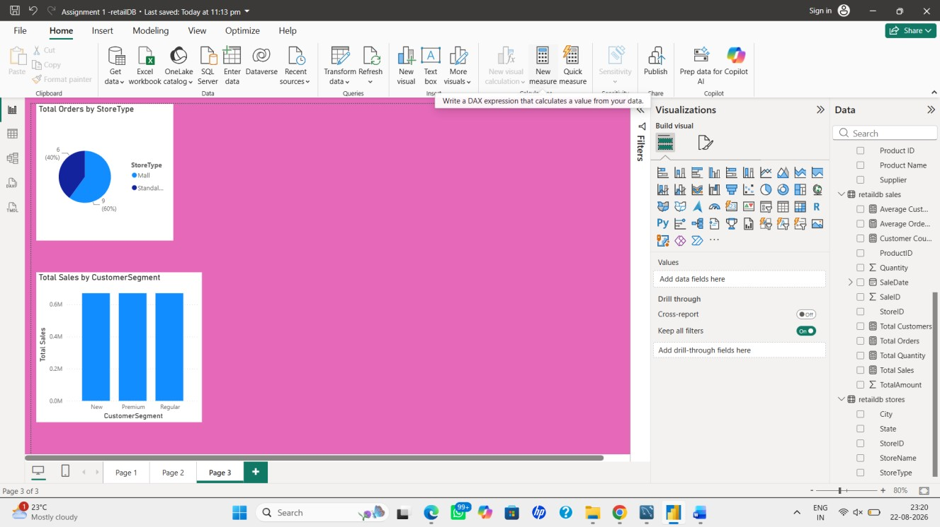

Conclusion
This project successfully integrated data from multiple sources into Power BI and transformed it into meaningful business insights. Data cleaning, transformation, and modeling techniques were applied to ensure accurate reporting. The developed dashboard provides a centralized view of business performance and supports better decision-making.

Business Insights
- Product Performance: Identified top-selling and low-selling products.
- Store Performance: Compared sales across different stores.
- Customer Analysis: Identified high-value customers and their sales contribution.
- Sales Trends: Analysis sales patterns across different time periods.
- Business Growth: Helped identify opportunities to improve sales, inventory, and customer targeting.

